**Output files and Performance evaluation results:**

1. **Deploying at least 3 super-peers and each super-peer is connected to 1-3 peer nodes. Ensure you can transfer one file properly and that multiple peer nodes can simultaneously upload and download files.**

Three super nodes have been deployed with one weak node connected to two of them and another two weak nodes connected to the third one. Each one of the four nodes has queried one file simultaneously. The results in the logs are the following:

* **Super nodes:**

**Super node 1:**

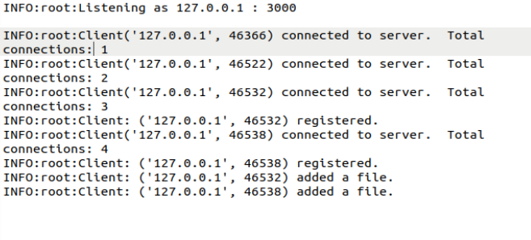

**Super Node 2:**

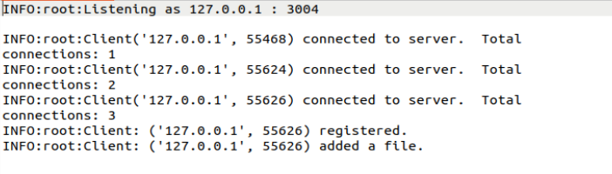

**Super Node 3:**

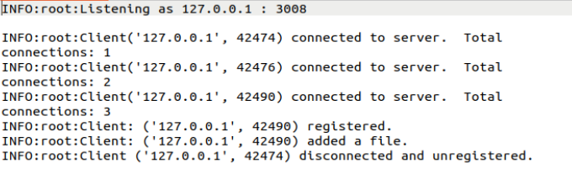

* **Weak Nodes:**

**Weak Node 1:**

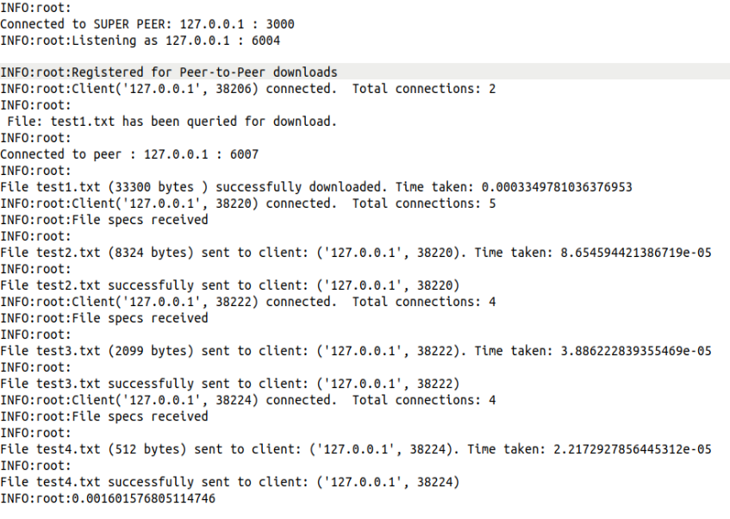

**Weak Node 2:**

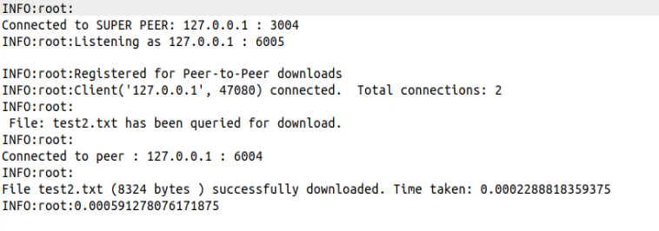

**Weak Node 3:**

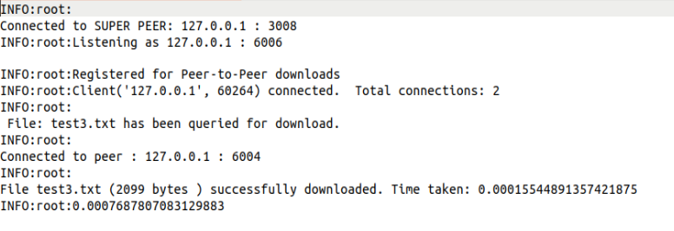

**Weak Node 4:**

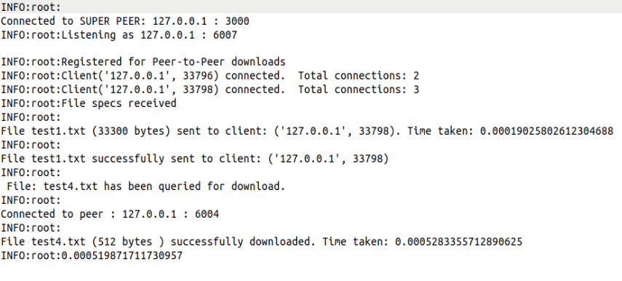

This evaluation has been executed with a bash script with an all-to-all topology. However, a manual evaluation of the serial topology has been carried out and the logs are stored in the Out folder in the path q1/linear.

In both evaluations, multiple nodes can download and send files simultaneously between them without any problems.

1. **Evaluate the system performance for two topologies for super-peers and then compare their performance. The tested two topologies are all-to-all topology and linear topology. You could initialize the topology by assigning the neighbors for each super-peer.**

As it was done in the previous assignment, to perform this evaluation, some arrangements have been made to the code. All the logs of the weak nodes have been disabled except for the one that prints the average time for the queryhits to ease the averaging of the 300 requests per node.

Then, two bash scripts have been created to automate the evaluation by generating different screens and run all the nodes simultaneously:

q2.sh <num_times> <num_nodes>

q2_l.sh <num_times> <num_nodes>

q2.sh performs the all-to-all topology evaluation while q2_l.sh performs the linear topology evaluation. The only differences between them are:

* Super nodes: The super-nodes neighbors assign to each one.
* Weak nodes: The argument ‘topology’ to define the TTL for the query messages. (TTL of 1 with all-to-all topology and a TTL of 9 (number of super nodes – 1) with a linear topology)

Is important to note that the results have been obtained while running the super nodes and the peer nodes in a virtual machine with 4 CPUs and 2 GB of RAM.

At the same time, it is important to highlight that in all the cases, the connections of the super nodes with themselves and with their weak nodes is stablished at the beginning of the evaluation and they do not get closed throughout it. Therefore, for both cases and no matter the total number of weak nodes issuing queries, the number of connections (that matter for timing the queryhit time) is constant. The results obtained are the following:

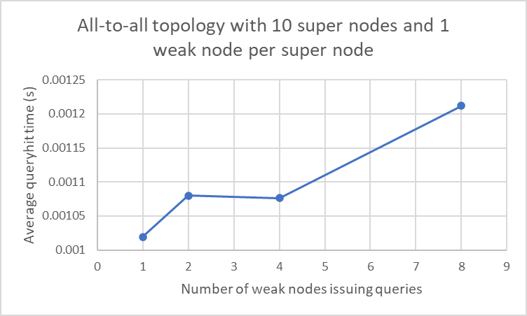

In this case, when a query is sent from a weak to a super node, this node broadcast the query to the rest of super nodes, but as the TTL for this configuration is 1, the rest of super nodes do not broadcast the query again. Hence, the total number of query messages generated for each file request is of 10 and the total number of queryhits messages travelling across the network is also of 10.

That is the reason why if more weak nodes issue queries simultaneosly, the average time to receive the queryhits in the weak nodes tend to increase (there are many more messages that the super nodes have to handle at the same time and the computing resources are limited).

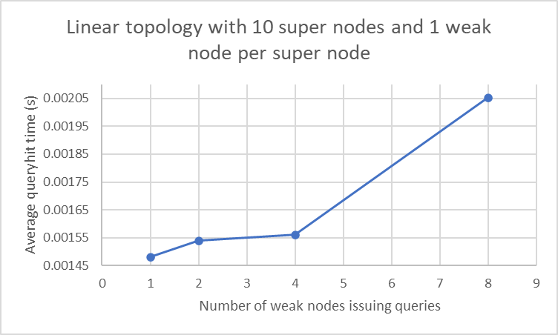

In the linear case, when a query is sent from a weak to a super node, this node broadcast the query just to the neighbour supernode that has not sent the message (it is always just one super node).

Hence, the total number of query messages generated for each file request is still 10 but, as the queryhit messages have to backpropagate through many super nodes, there are many more queryhits messages for each file request than with an all-to-all topology. This is the reason why, the average times to recevide the queryhits with a linear topology are greater than the ones with the all-to-all topology and the increase in time when there are 8 weak nodes issuing file requests is also significativaly greater.

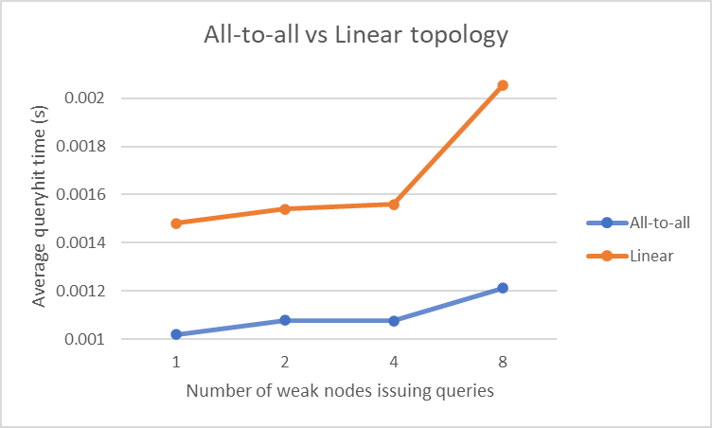

Finally, point out that as it was said before, the logs saved at the folder Out are just the average times taken to receive all the queryhits for the 300 query requests for all the weak nodes.